Wednesday, 27th March 2019

Nursery Homework

Topic: Animals
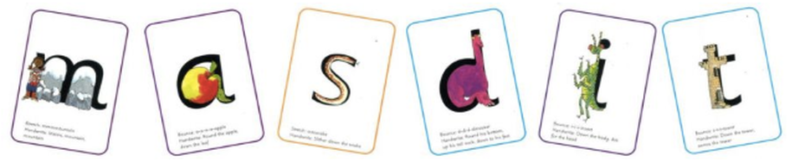
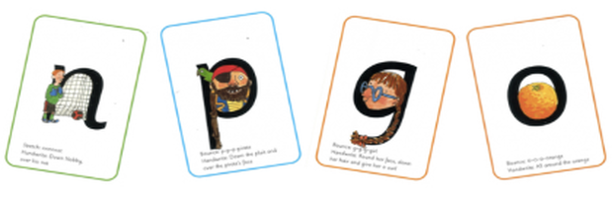

Our sound of the week: o
Jingle for handwriting “All around the orange.”
Activities to choose from:
- Find some things that start with ‘o.’
- This week our book of the week is a non-fiction book. An information book on tadpoles and frogs. The children enjoy finding out about these animals. Find out some more interesting facts about these or other animals. If possible make a picture in your homework book.
- ‘What’s in my box?’ Place something in a box. Ask questions to find out what it is. They can lift the box, shake it, smell it.

Could we please ask that Library books are returned to school next week.

Thank you, The Nursery Team

