18.10.19 Homework- Year 1
English/Spelling
Spelling test: Thursday 31st October 19
Focus sound for spelling- ai (snail in the rain).
- pain
- rain
- strain
- sail
- tail
- fail
Challenge word:  Faith | Red word:  what

Extension: Can you write a sentence using 1 of your spellings?

Maths homework
Can you show how to divide 10 in 3 different ways?
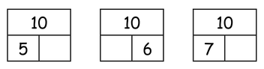
Find pairs of numbers that make 12
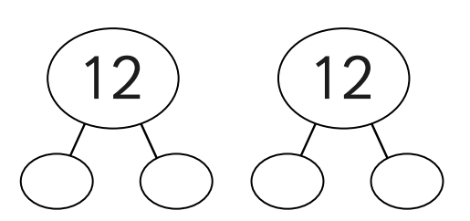

Find pairs of numbers that make 16
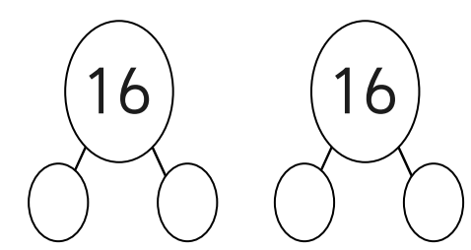
Challenge – Holly had 14 sweets. She gave 6 to Joan and 8 to Kate.
Can you show this using the part -part whole model?

