5/12/2019 Homework- Year 1
English/Spelling
Spelling test: Wednesday 11th December 19
Focus sound for spelling-(o-e – phone home)
Challenge word:  phone  code  joke  home  froze  chose  Challenge Word  lonely | Red word:  today

Extension: Can you write a sentence using 1 of your spellings?

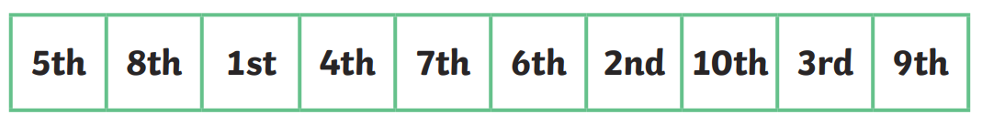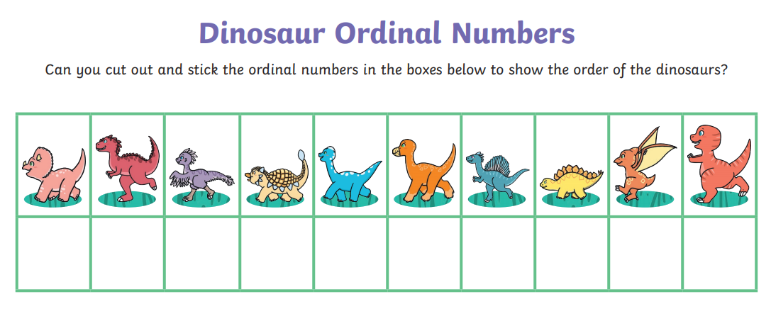
Challenge Cards
