Wednesday 15th January 2020
Nursery Homework
Topic: People who help us.
Our sound of the week: a
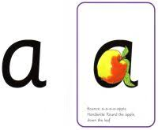

“round the apple, down the leaf”
Activities to choose from:
- Find some things that begin with the sound ‘a.’ Take a photo or draw one of them in your homework book.
- This week we have been reading a book about transport called ‘Choo Choo Clickety Clack.’ Look out for different kinds of transport as you are out and about. Perhaps take a photo and put it on Tapestry, then we can show it in class.
- Look out for numbers in the environment – can you recognise numbers up to 10?

Thank you to all the parents who added an observation to Tapestry. It is lovely to see what the children are getting up to outside of nursery. You are welcome to add observations/comments at any time. We would like all parents to add at least one observation each half term.
Please let us know if you have any problems using Tapestry.
Now that we have started phonics teaching, you may like to look at this website which has information for parents about our phonics scheme.
http://www.ruthmiskin.com/en/parents/

Thank you,
The Nursery Team

