Topic Project – Toys
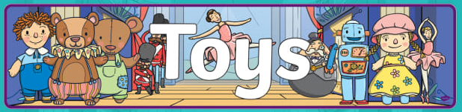
We have supplied you with a craft book for your exciting new Topic project which is based on your favourite thing – Toys! We want you to fill this book with pictures, writing and all your fantastic creative ideas. We will supply you with a learning objective and then it is up to you to make it as special as possible. When you return we will give you the chance to show your books off to the class and talk about all the wonderful things you have written and drawn.
Lesson 1
LO – I know how to write about my favourite toy using adjectives.
Example – what adjectives would you use to describe this teddy?
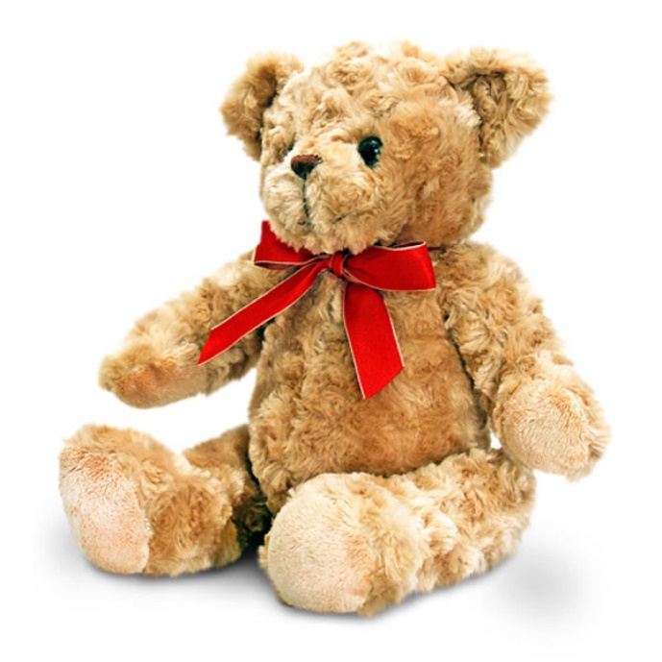
soft

We would like you to choose your favourite toy and write about it using adjectives. What do you like about it? Where did it come from? You can also take pictures of it, draw it and stick these, along with your writing into your book. Enjoy!

Lesson 2
LO – I know about the history of toys.
First read about the history of toys with an adult and discuss what the
toys were made from, what you notice about them and talk about why they were popular at the time.
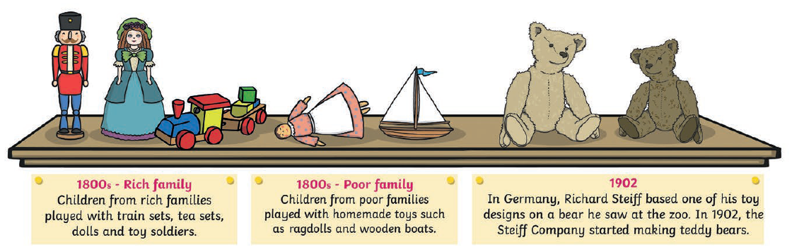
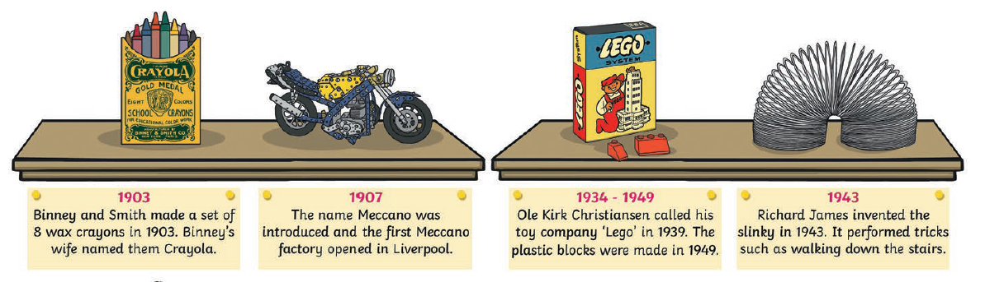
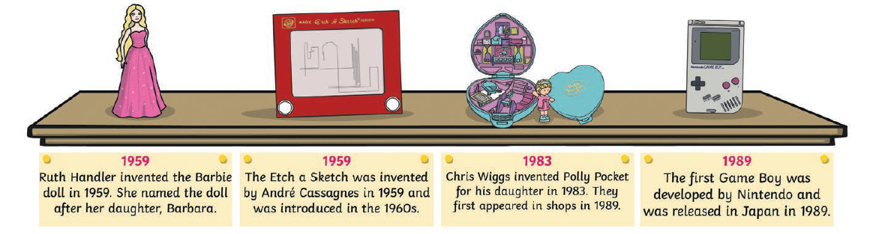
Research the history of toys using the internet with an adult and then get creative!

Ideas
- You could make a timeline
- You could draw pictures of toys from past.
- You could print off some photos and make a collage.
- You could investigate what materials were used to make toys and why.
- The options are endless!
Lesson 3
LO – I know about the history of toys.

How could we find out about toys from the past?

- Ask your parents/grandparents
- Research in the library
- Research on the internet with an adult
- Visit museums
- Watching film from the present and the past.

Here are some toys from the past…
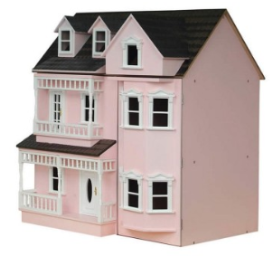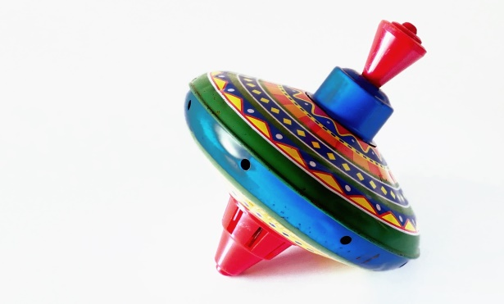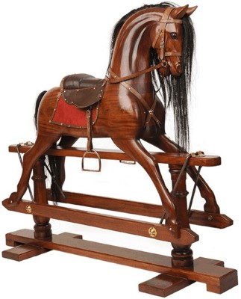

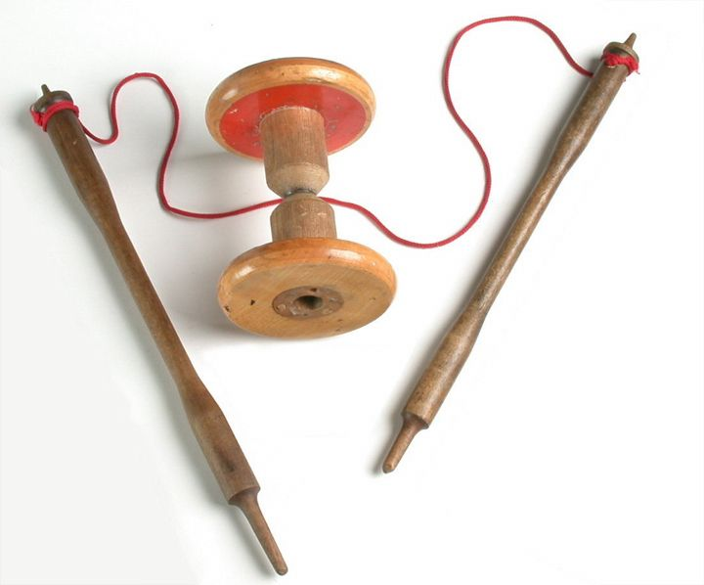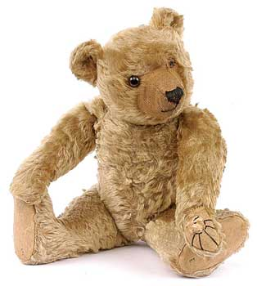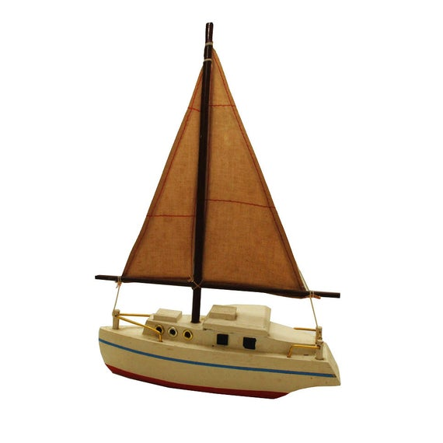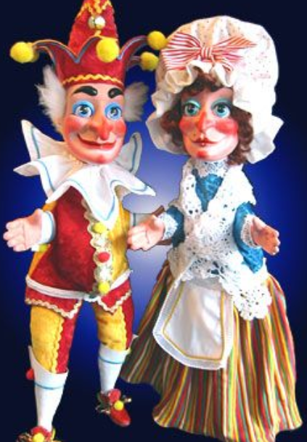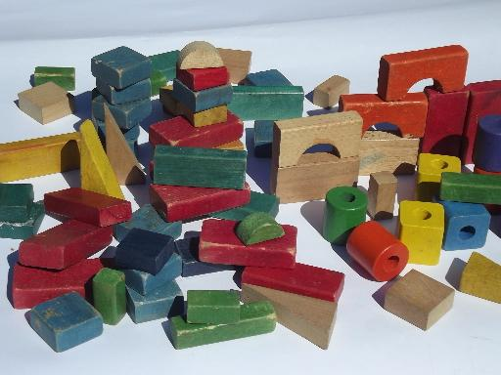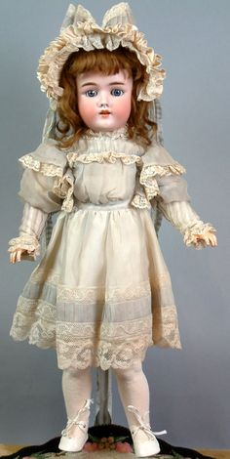

Can you pick one of these toys and research it?
Things to think about…
- When was it invented?
- What was it made from?
- Why was it popular?
- Who would have been likely to own one?
- Is it still around today?

Write about the history of your chosen toy, draw picture, cut out images to make collages and make sure you find out as many facts as you can about it.

Lesson 4

LO – I can compare old and new toys.
Write a list of toys from the past and a list of toys from today.
Think about
- What they are made from
- How they work
- How they were made
- How safe they were

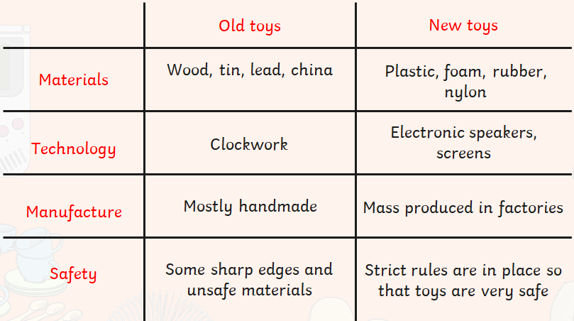

Why do you think old toys were made from natural materials?
Why did old toys not use batteries>
Why were they mostly handmade?

Use the following chart to list the differences and make sure you stick
it in your project as evidence!

Differences Between Old and New Toys

Old Toys | New Toys  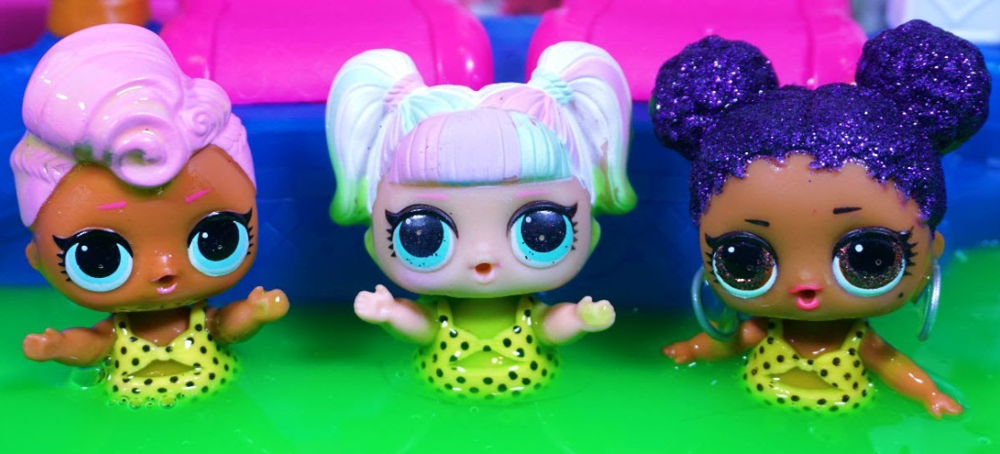

Lesson 5
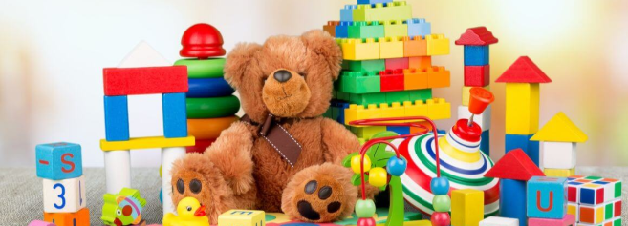

LO – I know how to sort old toys and new toys.

Look at the pictures below and see if you can sort them into old toys, new toys and toys from the past that we still have today. Remember to cut out carefully and stick all the corner down. No flappy corners!

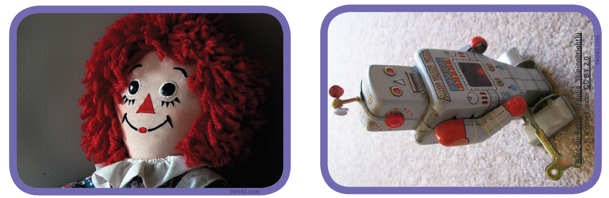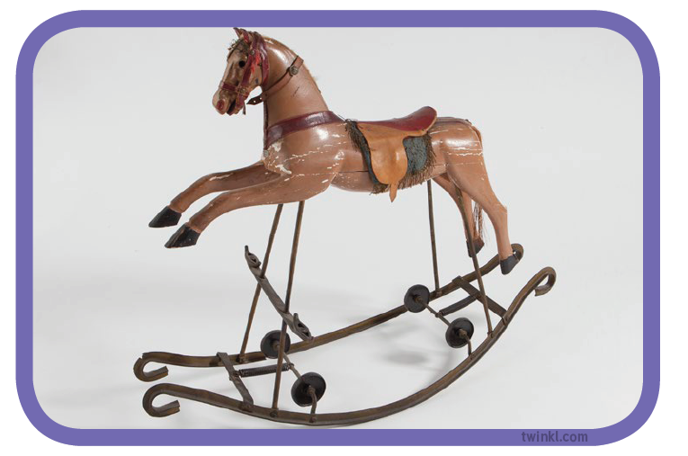

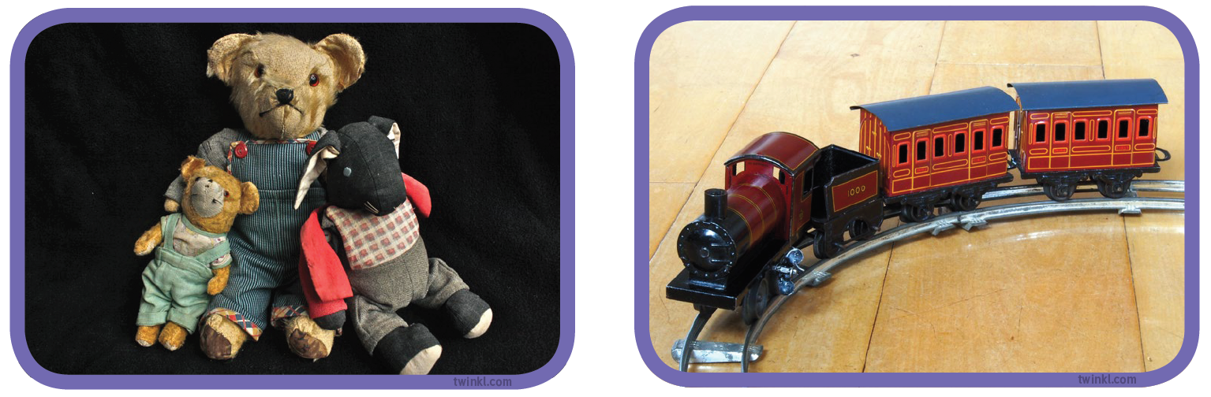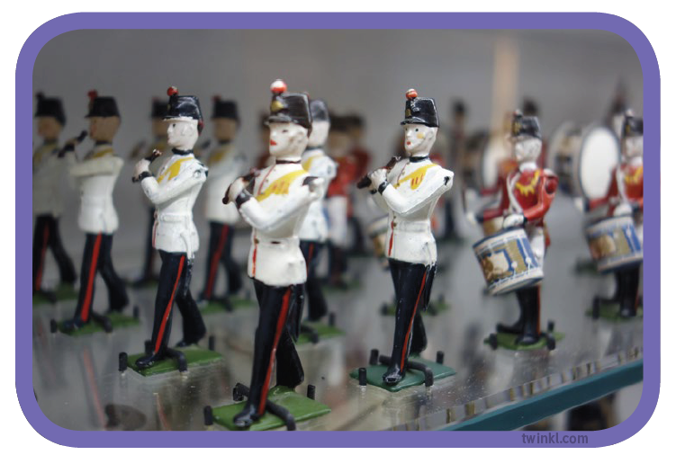

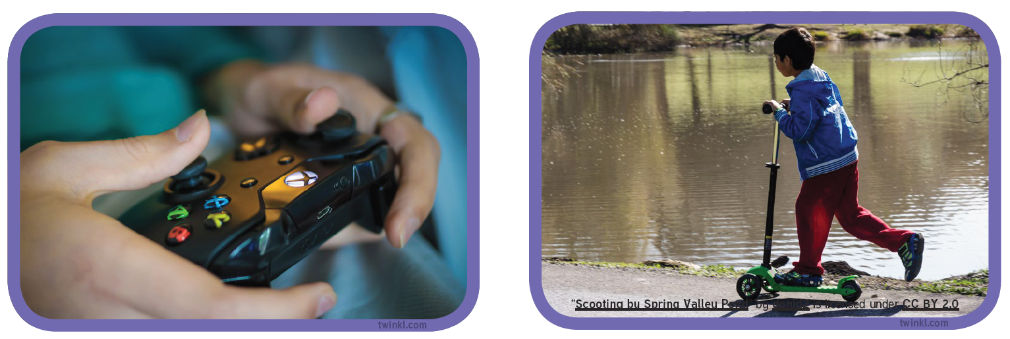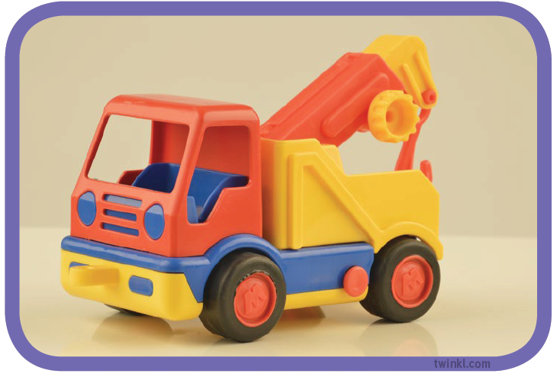
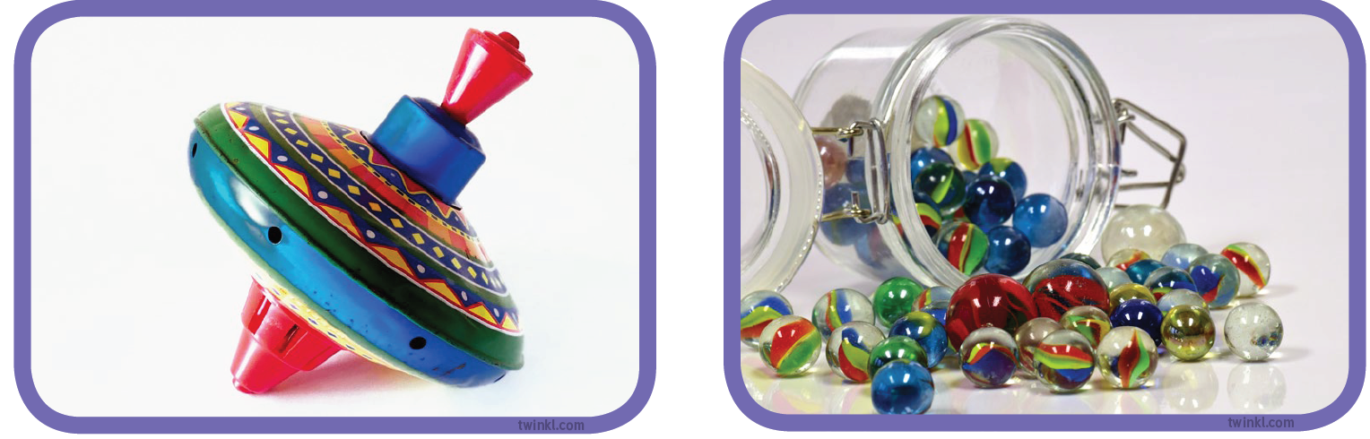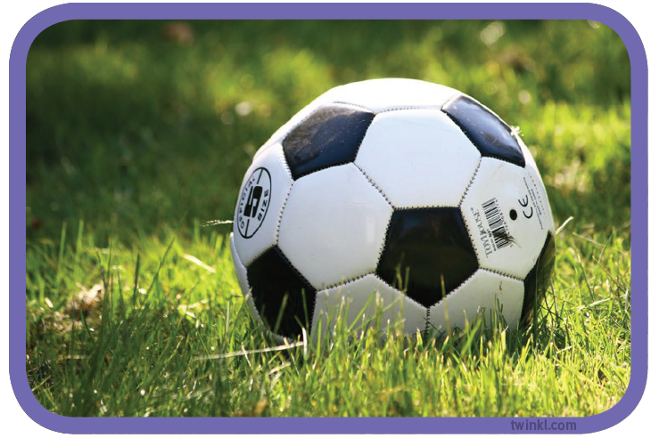
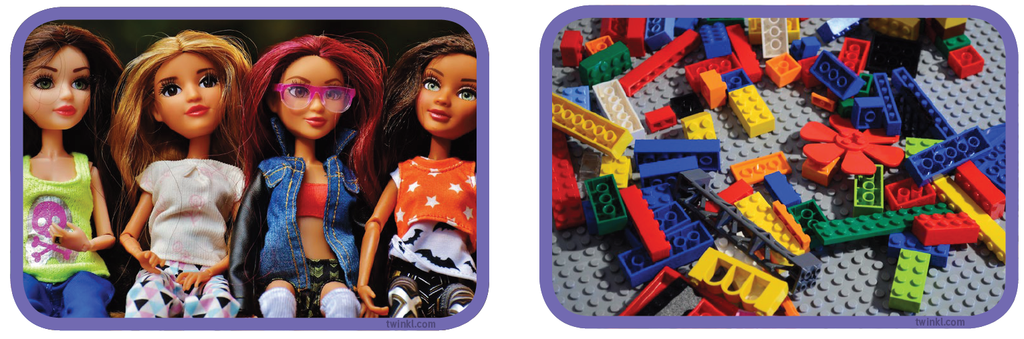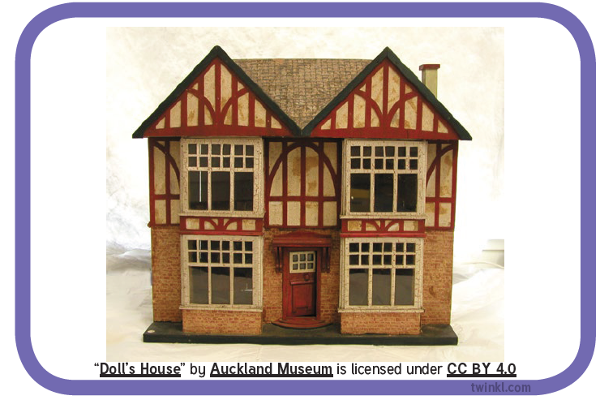
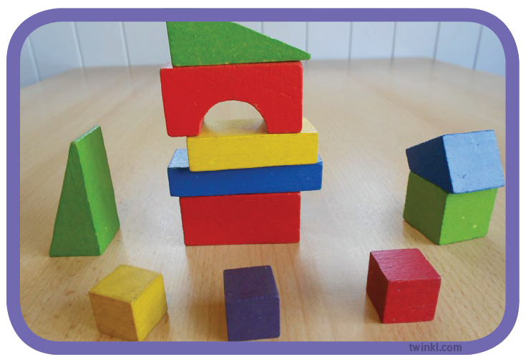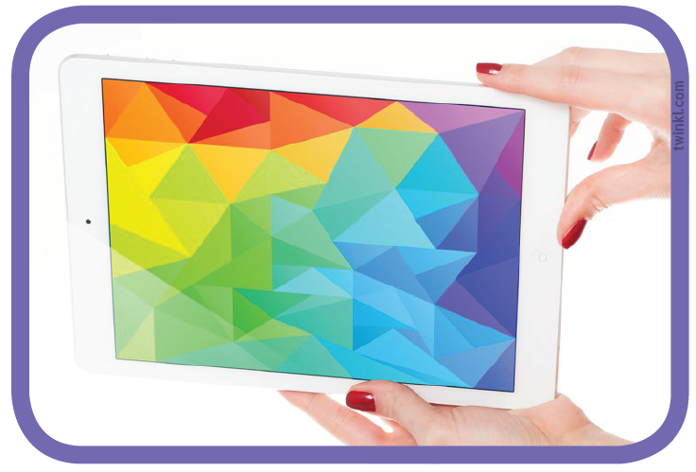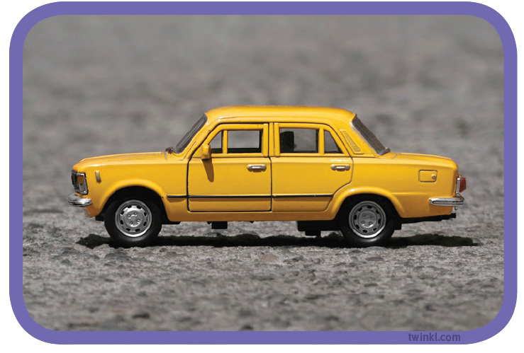

Lesson 7
LO – I can write an acrostic poem about a toy.

What is an acrostic poem?

The softest fur
Everbody loves him
Dappled with stains
Delighfully cuddly
You are the best!

What do you notice about the poem? Why is the first letter in red?

An acrostic is a poem is when the first letter of each line spells out a word.

Choose a toy and write your own acrostic poem about it. You can do full sentences or just one word for each line if you prefer. When you return to school we can read some of these out to the rest of the class.

Lesson 8
LO – I know how to answer questions about a story.
Read the story below either alone or with an adult’s help.

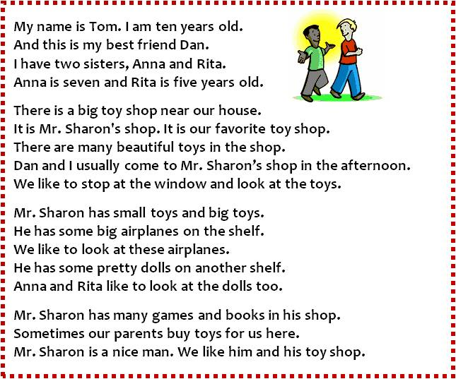

Can you answer these questions on the story?

How old is Tom? ____________________________________________________________________________________
What are his sisters called _______________________________________________________________________
When do they go to Mr Sharon’s shop?______________________________________________________
What toys do Tom and Dan like best? _______________________________________________________
What toys do Anna and Rita like? ____________________________________________________________
What else does he sell? ____________________________________________________________________________
What adjective is used to describe Mr Sharon? __________________________________________

Can you draw a picture of Mr Sharon’s toy shop below? Make sure you include the characters from the story and the details about the shop itself.

Lesson 9
Reading Comprehension
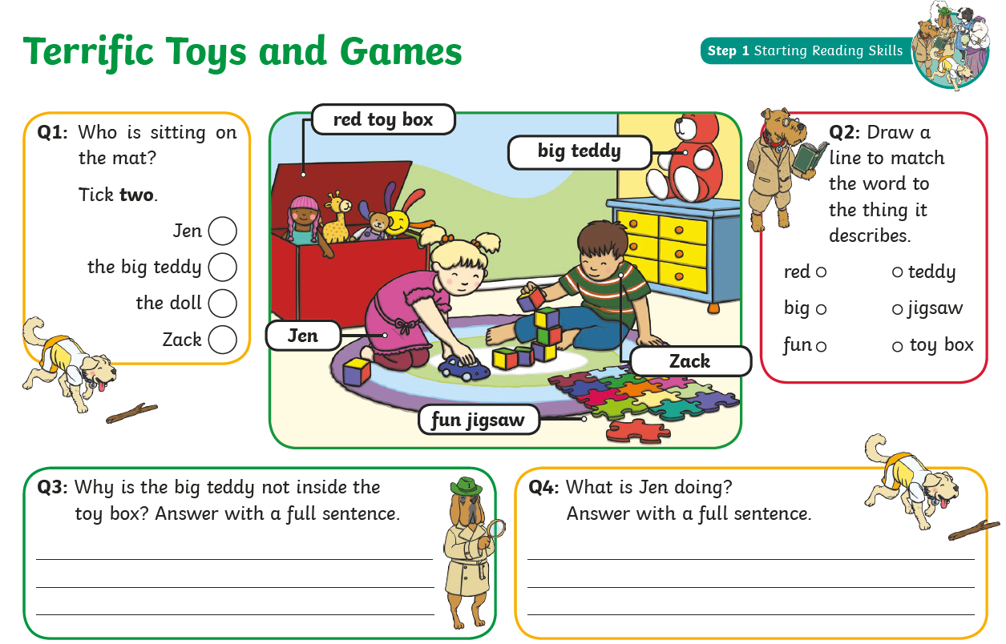

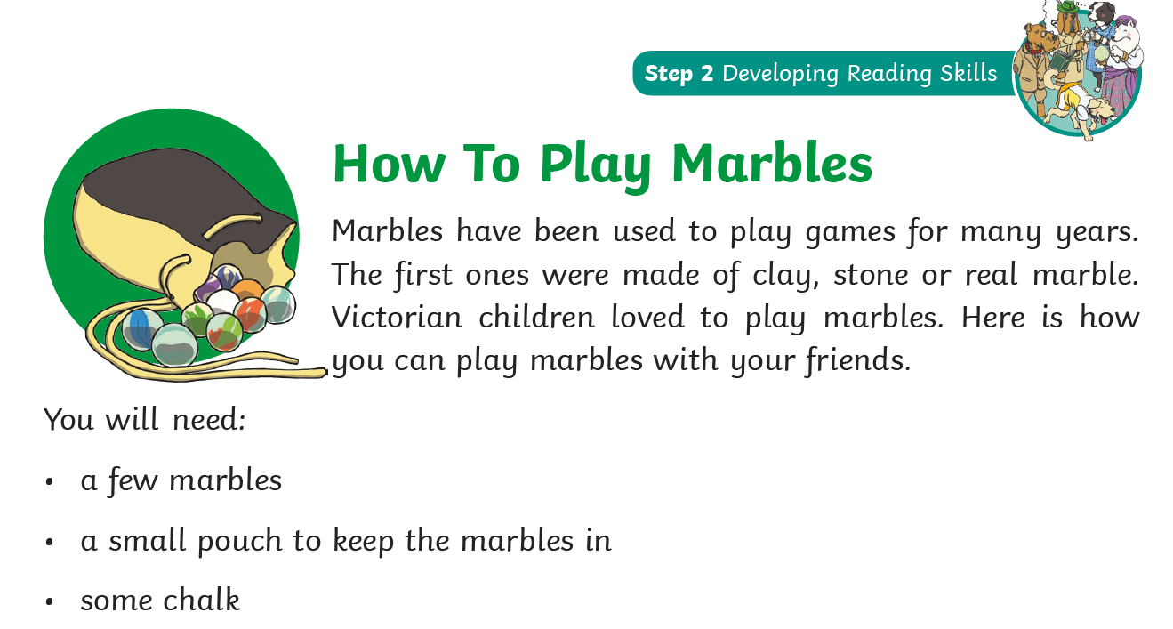
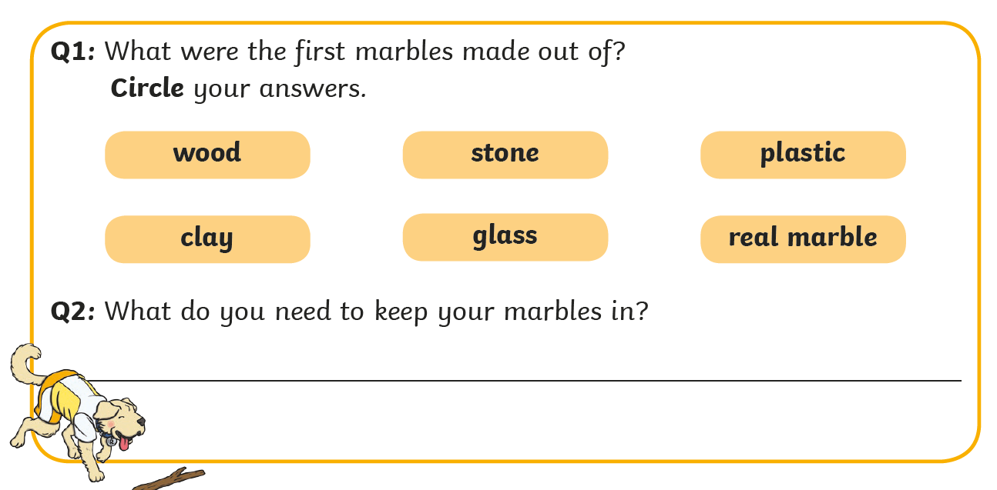

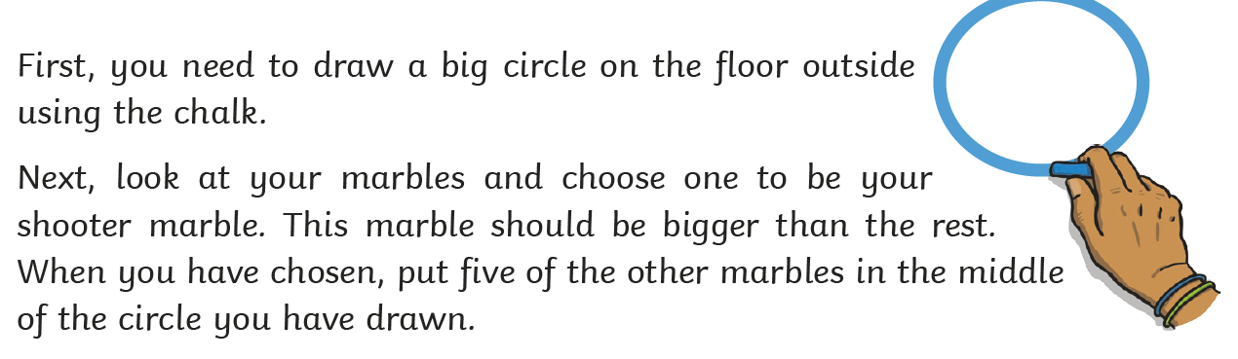
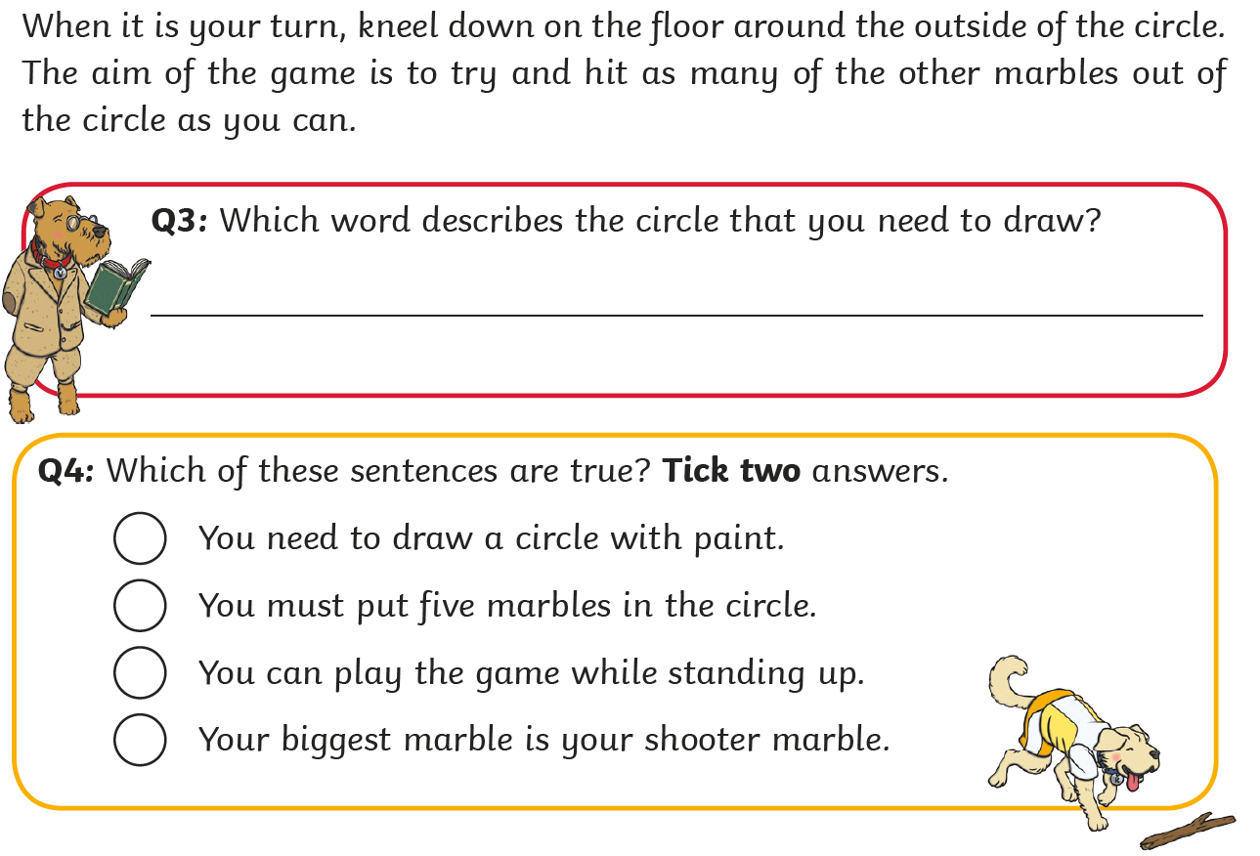
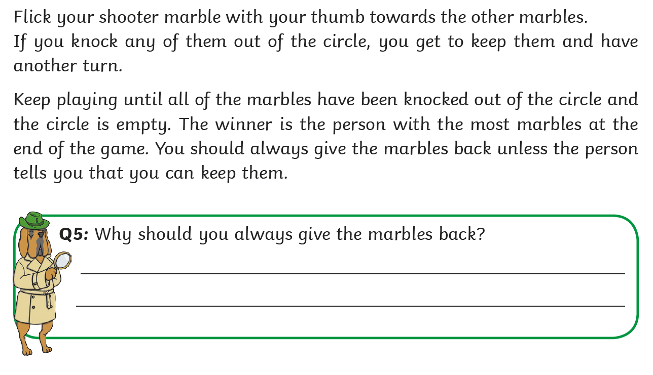
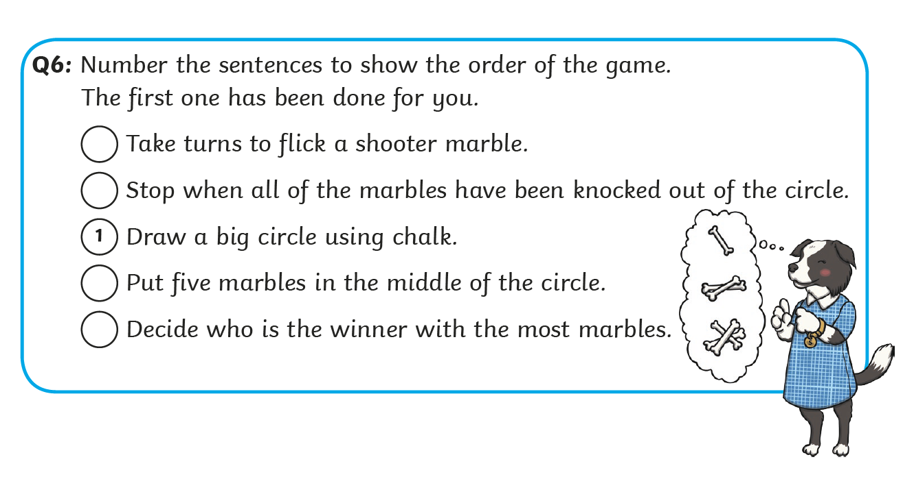
Lesson 10

LO – I know how to write a story about an adventure.
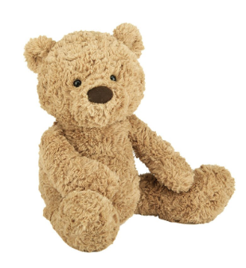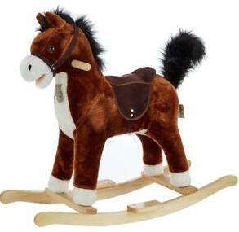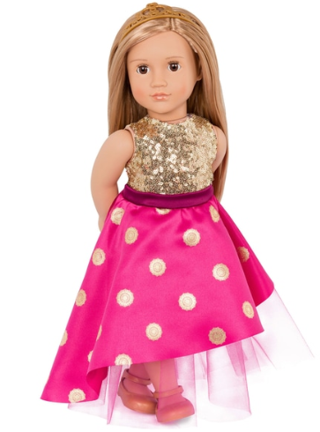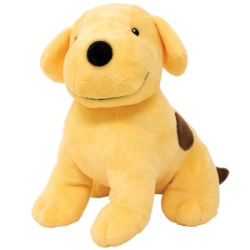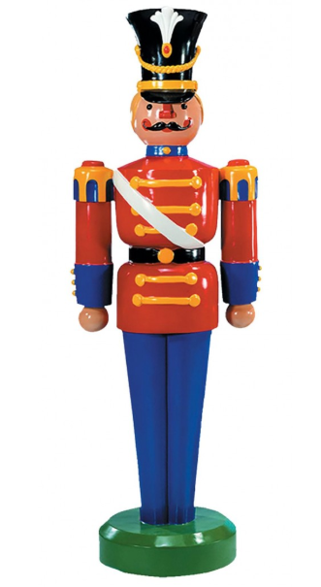

Each night after you go to sleep your toys come alive! Pick one of your favourite toys and write about an adventure that takes place.
Things to think about –
- Capital letters
- Full stops
- Finger spaces
- Adjectives
- Time connectives

Lesson 11
LO – I can research an artist.

Andy Warhol was a Pop Artist.
He used screen printing to create lots of prints that looked the same.
He used repeated images to make patterns.
In 1983 he created a series on Toys.
Can you research these with an adult and create your own Andy Warhol-style art work?
Use the images below to inspire you!
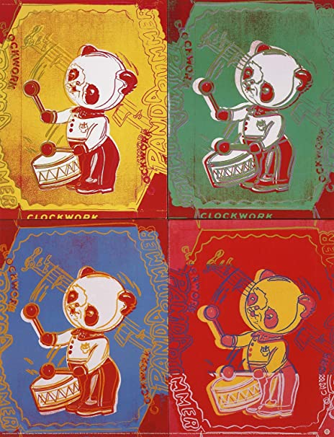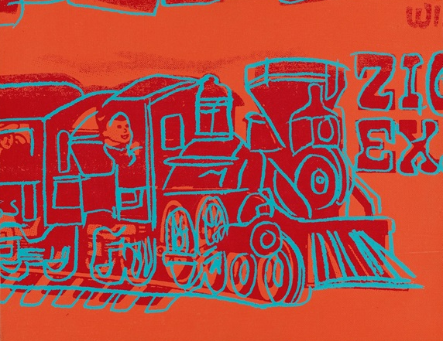
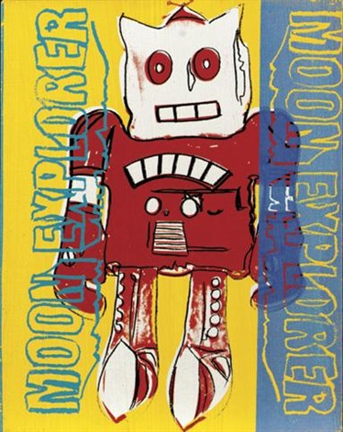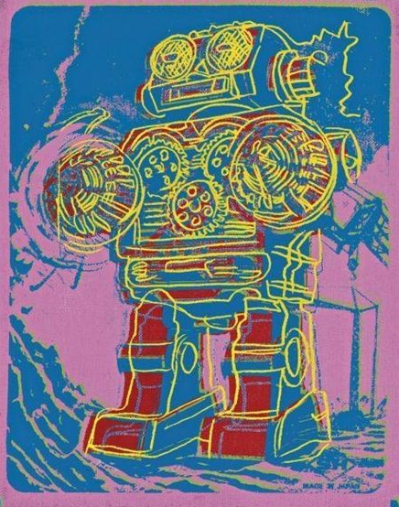

What do you notice about his painting?
What colours does he use?
Are they similar to any other artist’s work?

Writing –
Can you write an Andy Warhol Fact File?
You could include:
Where was he born?
What is he famous for?
What techniques did he favour?
Where did he live and study?
Lesson 12
LO – I know about toys from around the world.

Children from all around the world play with toys but these differ from country to country.We have included some examples below.
Ghana India
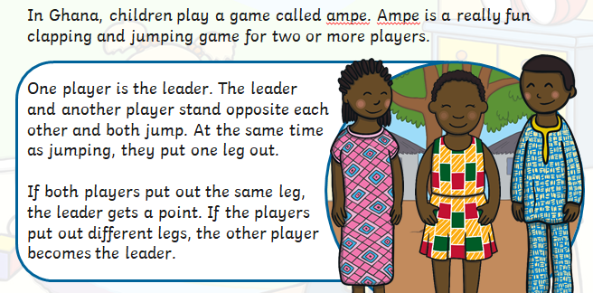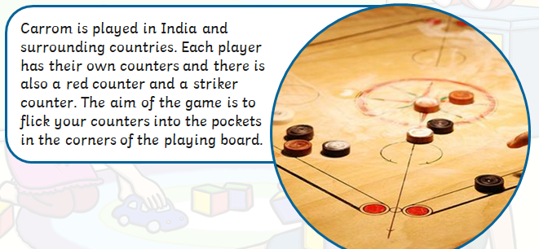

The Phillippines Poland
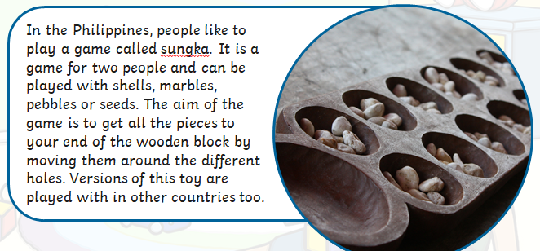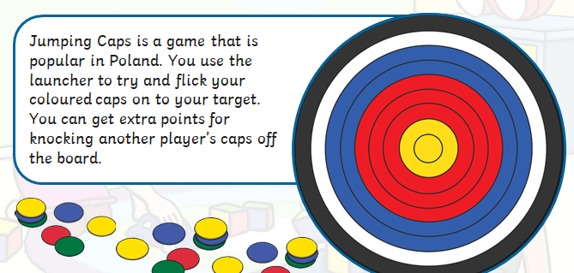
Zimbabwe Russia
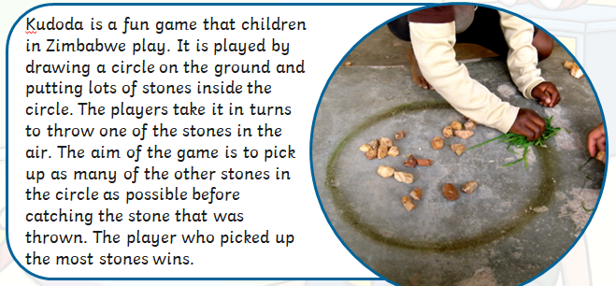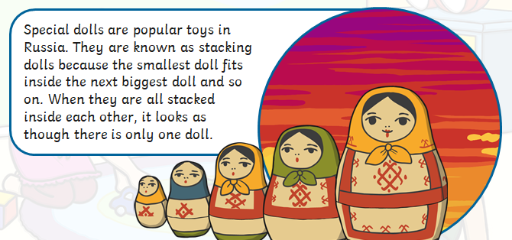
Guatemala
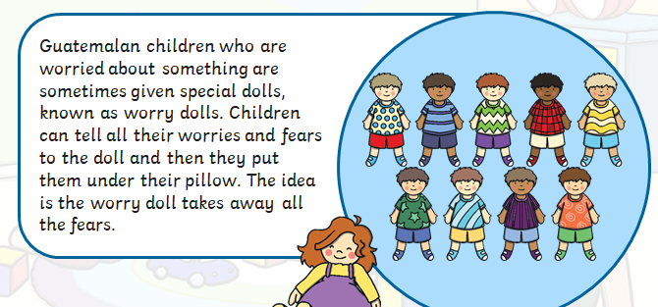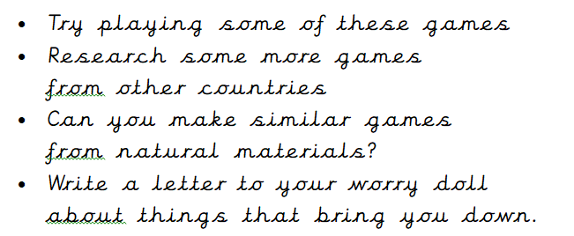

Lesson 13

LO – I can design an advert for a toy of my choice.

Think about the types of toys that children of different ages play with. How might a toy for a baby differ from a toy for a seven year old?

Think about the toys that girls and boys might play with. Do toys have to be especially for boys or girls, or can they be used by both?

Think about the instructions that will need to be included with your toy.

What would make someone want to buy your toy? What special features has it got.

