Film Club – Lockdown Edition

Many of you have been involved with Film Club over the last couple of years. Part of what makes Film Club special is the gathering together (with cake) to watch and respond to something really interesting. However, the other part of what makes it special is the act of becoming a film critic by writing reviews afterwards, with the chance of winning a prize and having your review displayed for thousands of schoolchildren in other Film Clubs to see.
All of Upper Key Stage 2 now have the opportunity to join in the fun. Below, you will find a link on how to register with Into Film, the part of the British Film Institute, or BFI, that deals with film clubs all over the UK. Here’s the deal: you follow all the login instructions in the link just below, watch – or re-watch – one or more of my weekly recommended films, and then submit your review on the IntoFilm website. If you write a well-thought-through and incisive review, you may find a DVD winging its way to you in the post. The films you watch don’t have to be new to you; sometimes it can be really eye-opening to watch something you saw years ago with fresh, critical eyes.
https://stmichaelsn6.com/year-5-homework-list/film-club-lockdown-instructions/
Each Monday from now on during the shutdown I will post three film titles in the Year 5 section of the St Michael’s homework page. The films will all have a theme in common (if you think you can guess it, then say so in your reviews). They will usually be very different, and usually one (marked with an asterisk) will be recommended for more mature viewers on the basis of format, theme or content. For convenience, here are next Monday’s now:
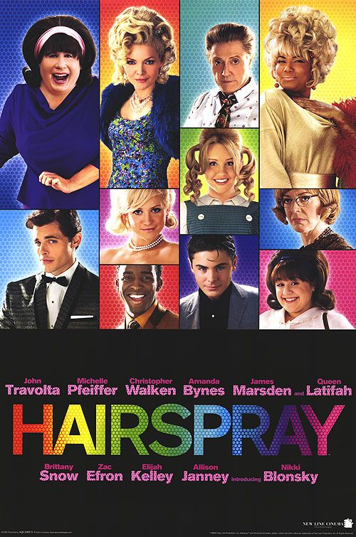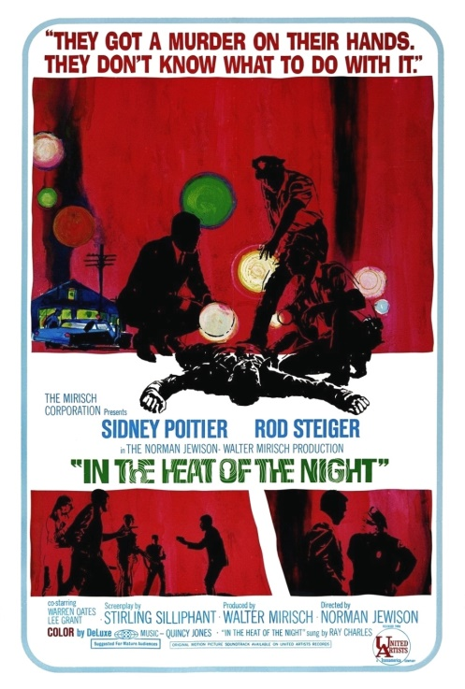
Hairspray, 2007, PG Hidden Figures, 2016, PG In the Heat of the Night*, 1967, 12A
Important note for parents and carers:
Due to time constraints, I will not go into detail when recommending films. As always, I recommend IMDB (Internet Movie Database) for opinion-free commentary on a film’s content. The BBFC also has some fascinating insights – and original certification essays which are pieces of movie history in themselves. It’s also useful to see how a film’s certification can change over time or with just the removal of several seconds of footage. At the end of the day, not all of the films I recommend are suitable for all children, and it is your responsibility to make an informed choice about whether something is appropriate for your child.

