Frog camouflage
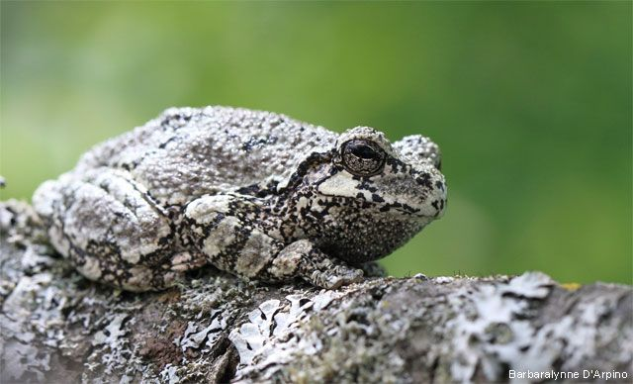
Did you know?
Frogs have many predators such as fish and birds. Some frogs protect themselves by climbing up into trees using sticky hairs on their fingers and toes. Other frogs are very good at camouflaging themselves, meaning they can blend in with their environment. A frog can even change its skin depending on its environment. That is why we find many different colours of frog all over the world.
This week your project is to find out about frog’s camouflage and using felt pens or crayons design your own camouflaged frogs.
What you will need:
- Crayons/Pens
- Drawn or cut out frogs (see frog outlines included below)
What to do:
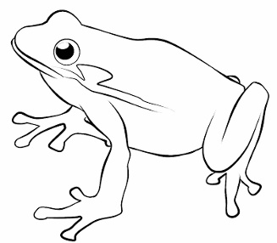Look around your house or garden and notice the colour of the surroundings e.g. the sofa, grass, carpet etc. Using pens or crayons colour the frogs, so that they can blend in (match) these colours. Cut out the frogs and place them around your home or garden. Then try playing ‘Hide and Seek’. Can your parents spot them? Take pictures and upload these to Tapestry Journal so we can see your amazing designs!

What are the benefits?
This activity is a great way to support children’s learning through play. It supports fine motor and communication and language skills.
Next steps:
What other animals use camouflage? Which of these is your favourite and why?

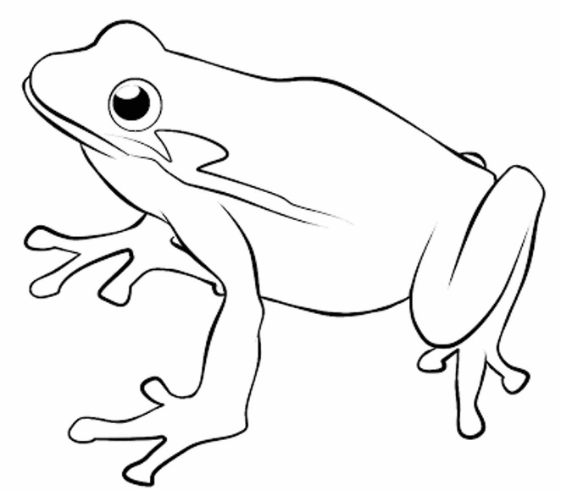

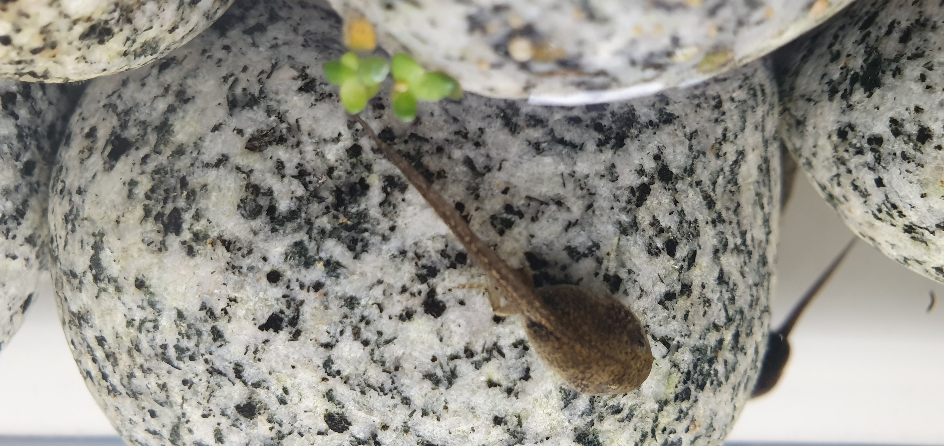
Dear Pele and Bronze Class,
The frogs are now over five weeks old and guess what some have started to grow back legs!
They use these legs so help with swimming and soon they will even be able to climb out of the water. Now they are part tadpole and part frog and are called froglets.
In the next few weeks, they will start to grow arms and their tails will get shorter, then I will have to start feeding them insect pellets.
The froglets really need some names now. Can you send me some good suggestions? Please write and put them onto Tapestry. I will use these names and make the froglets some name badges!
Yours sincerely
Mrs Razvi and the froglets

