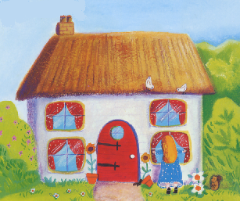
Three Bear Cottage
Buttercup Lane
The village

Dear Daddy Bear, Mummy Bear and Baby Bear,

___________________________________________________________________________

___________________________________________________________________________

___________________________________________________________________________

Love from Goldilocks
x

