Grammar Focus – Adjectives

Explain to your child what an adjective is. We have done a lot of work on adjectives so hopefully they will already have a firm idea that an adjective is a ‘describing’ word.

Get them to describe objects in the room/or outside using adjectives.

Can you think of an adjective to describe these three pictures?

_______________________ ______________________

___________________ _________________

Can you add an adjective to these sentences below?

The cat felt ________ and ________ when she stroked him.

The class were ____________ when the angry teacher walked in.

The girl was a _______________ football player.

Bolt and Thompson classes are _____________ at reading.

The boy thought his packed lunch looked _____________.

Now write two of your own sentences of your own including an adjective.

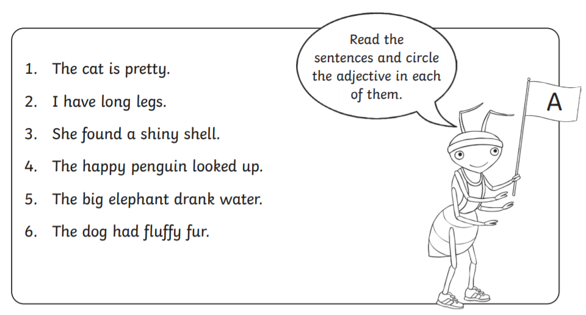
Challenge!
Can you think of an adjective for every letter in the alphabet?
Work with a parent using a dictionary if you get stuck.

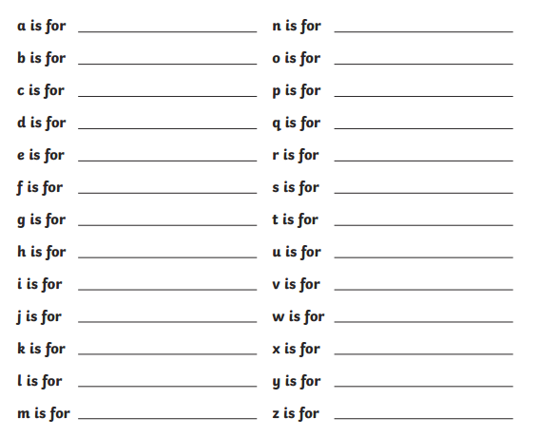
Powerful Adjectives

Powerful adjectives add depth and excitement to a story.
For example

- very beautiful = gorgeous.
- very busy = swamped.
- very crowded = packed.
Can you rewrite these sentences and swap the adjective to a new and more exciting powerful adjective?

The cake tasted very nice.
______________________________________________

The girl was very scared.

The flowers looked very pretty.

The monster was very big.
______________________________________________

The soldier was very brave.

The kitten was very sad.
______________________________________________

Can you write your own powerful adjective sentence below?

______________________________________________

