Guidance for home learning, Y1
Year 1 Maths: National Curriculum guidance.
- Statutory requirement: Multiplication solving one-step problems involving multiplication and division, by calculating the answer using concrete objects, pictorial representations and arrays with supported help.
- Non-statutory: Through grouping and sharing small quantities, pupils begin to understand: multiplication and division; doubling numbers and quantities; and finding simple fractions of objects, numbers and quantities. They make connections between arrays, number patterns, and counting in twos, fives and tens.

Repeated aggregation structure/ Repeated addition:
- This is the idea that multiplication means ‘so many lots of’ or ‘so many sets of’
- 10 sets of 3 counters
- ‘How many counters altogether? Is related to the multiplication question 3 x 10
- SEE PHOTO below.

KEY LANGUAGE:
If have place key language in bold, it might be helpful to write these on coloured paper or post it notes. Always encourage your child to refer to these.
- … many sets/lots of …
- How many (how much) altogether,
- Per,
- Each.

We will post support and guidance with activities that are set for your child. There are also lots of great resources available online via BBC Bitesize https://www.bbc.co.uk/bitesize/articles/zkjv382 and also here from the national academy providing video support https://www.thenational.academy/year-1/maths/to-problem-solve-using-doubling-and-halving-year-1-wk1-5/#

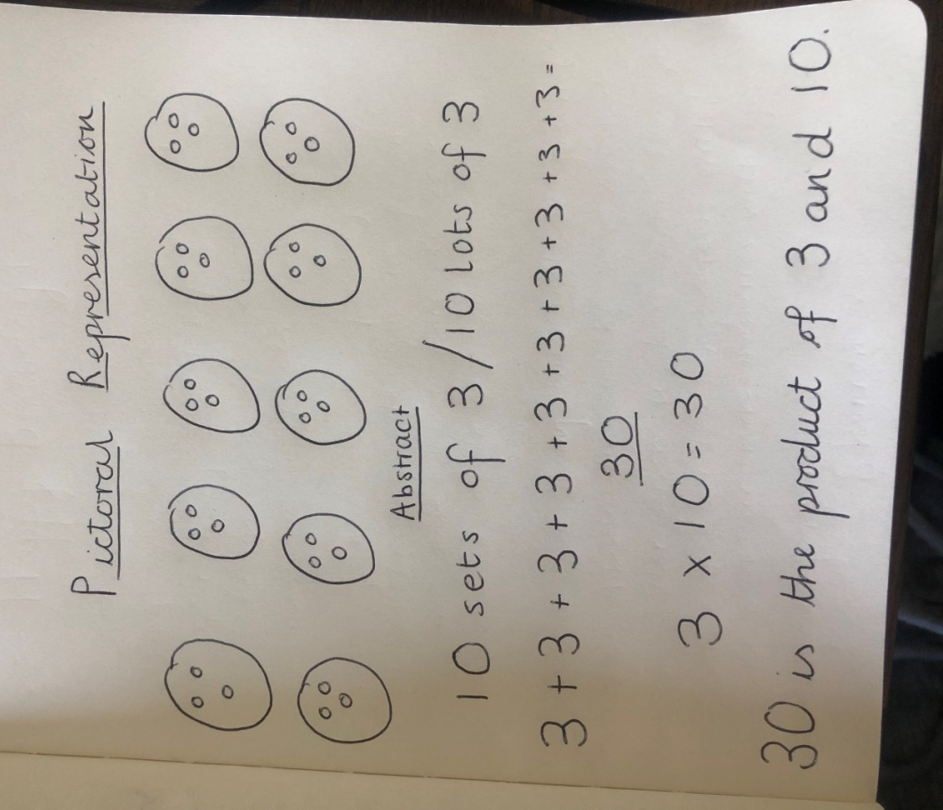
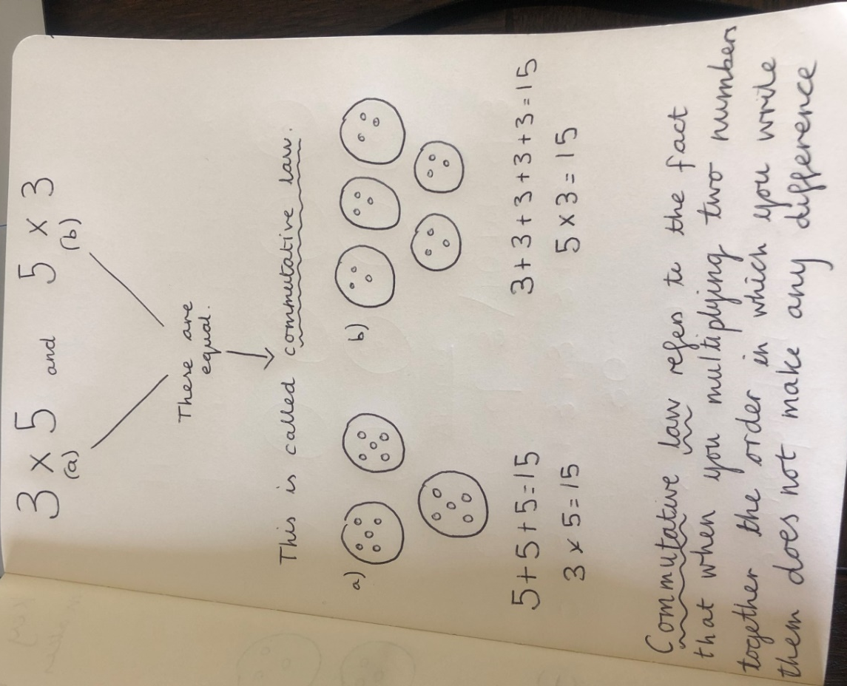

In those picture representations above, the idea of them being equal is not obvious. This is where the use of an array is used to support the understanding of commutative law helps, pictorially.
Arrays:
