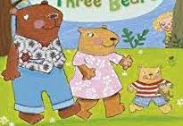
Goldilocks Cottage
Tulip Lane
The village

Dear Goldilocks,

We are writing to check that you are ok? We are worried because you ran away so quickly from our cottage.

Please write back to us to let us know you got home safely.

Love from The Three Bears
x

